Mona Lisa painting artwork
Name
Institution

Image and its Citation
Mona Lisa is one of the most top paintings in the world. It is the best and famous artwork on the globe. Below is the painting artwork by Leonardo da Vinci that represents Mona Lisa.
MONALISA ARTWORK BY LEONARDO DA VINCI
Elements of artwork
Colour
Texture
Line
Shape
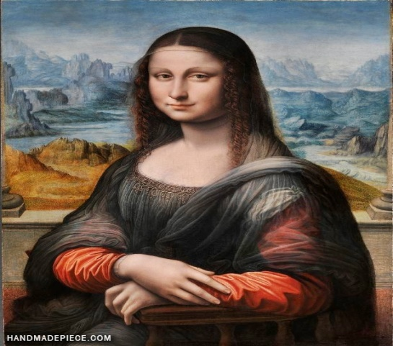
77X53 cm
Painting by Leonardo Da Vinci

Context Research on artist life
In world history, Leonardo da Vinci is well known inventing flying the machine. Besides, he was the most known renaissance painter, draftsman, architect, and engineer who was brilliant intellect and gifted with a mind of curiosity. Moreover, he lived within artworks made by his peers like Michelangelo and Raphael. All these aspects, as well as his creativity, influenced him to make Mona Lisa painting artwork.

Image Type
The image type is realistic as the artist tried to be so natural that he represented the artwork truthfully with no artistic convection and supernatural elements of artistically created work. As evident in this artwork, the image resembles a real human being from eyes, mouth, lips, hair, and hands. The artwork looks like a high-resolution photograph. The artwork seems real as the style used makes it appear as accurate to life and as realistic as possible.
It looks like a living painting that seems to be seeking to represent a life lived by Mon Lisa. Realism, according to sawyer (2020), is where artists focus on being true through their work. The rationale here is to relate certain concepts and meanings to the audience as well as emotions. Such artwork is portraying some message to the audience in a manner that can impact them positively.
Literal Visual Description
Apart from the name and meaning of this artwork, the elements of the artwork are visible. Colour, texture, shape, and lines can be seen. The artist tried to use some aspects of art or principle of art and designs. Some elements include colors, texture, lines, and shapes. The use has made the artwork of blue, black, white, and orange. Blue and white paints have been used as the background for the paintings. The artwork has a very smooth texture, especially around the face. Different shapes and lines have been used to create major components of the artwork, like eyes, nose, and lips.

Interpretation
In this work, the artist is trying to express the idea of happiness. Happiness turns to be the central motif of work hence making work ideal. Leonardo da Vinci is trying to send a message of smile that suggests the idea of happiness. As evident, he did not pain male creation, and thus he is trying to show how the female is more critical creation compared to men, and for this reason, he expressed his feeling on women's role in creation by painting Mona Lisa Portrait. This means that the painting was done in search of truth and reality about the source of human life (Read love, 2015).
Introspection
Contempt is a negative character trait in me that has been changed since I began studying this work. Before I started to study this artwork, little did I know about the role of a female in creation? Biblically I knew a woman was created out of man's rib and thus should not be represented as significance. However, after studying this work, I am now much aware that males and females are equally important and should be treated with equality; hence disregarding any of them is inhuman.

References
Read love, (2015). Da Vinci's Mona Lisa and Her Many Mysteries
Sawyer. W. (2020). Realism In Art: What it means & why it’s Valuable for Practicing Artists

